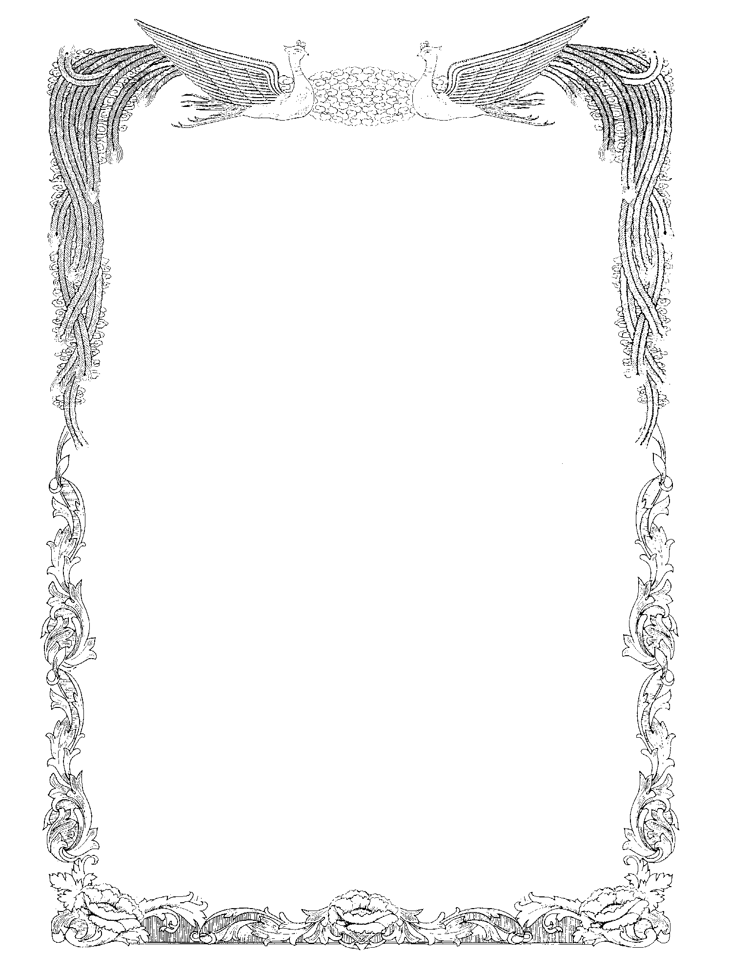
７ 修了証

Aichi Prefectural

Heisei Senior High School

John Smith

attended the General Course at Heisei Senior High School
from September 1, 2004 to June 18, 2005
and is therefore awarded this

Certificate of Attendance

Given by Aichi Prefectural
Heisei Senior High School,
this month of June, 2005

愛知 太郎
Taro AICHI
Principal

