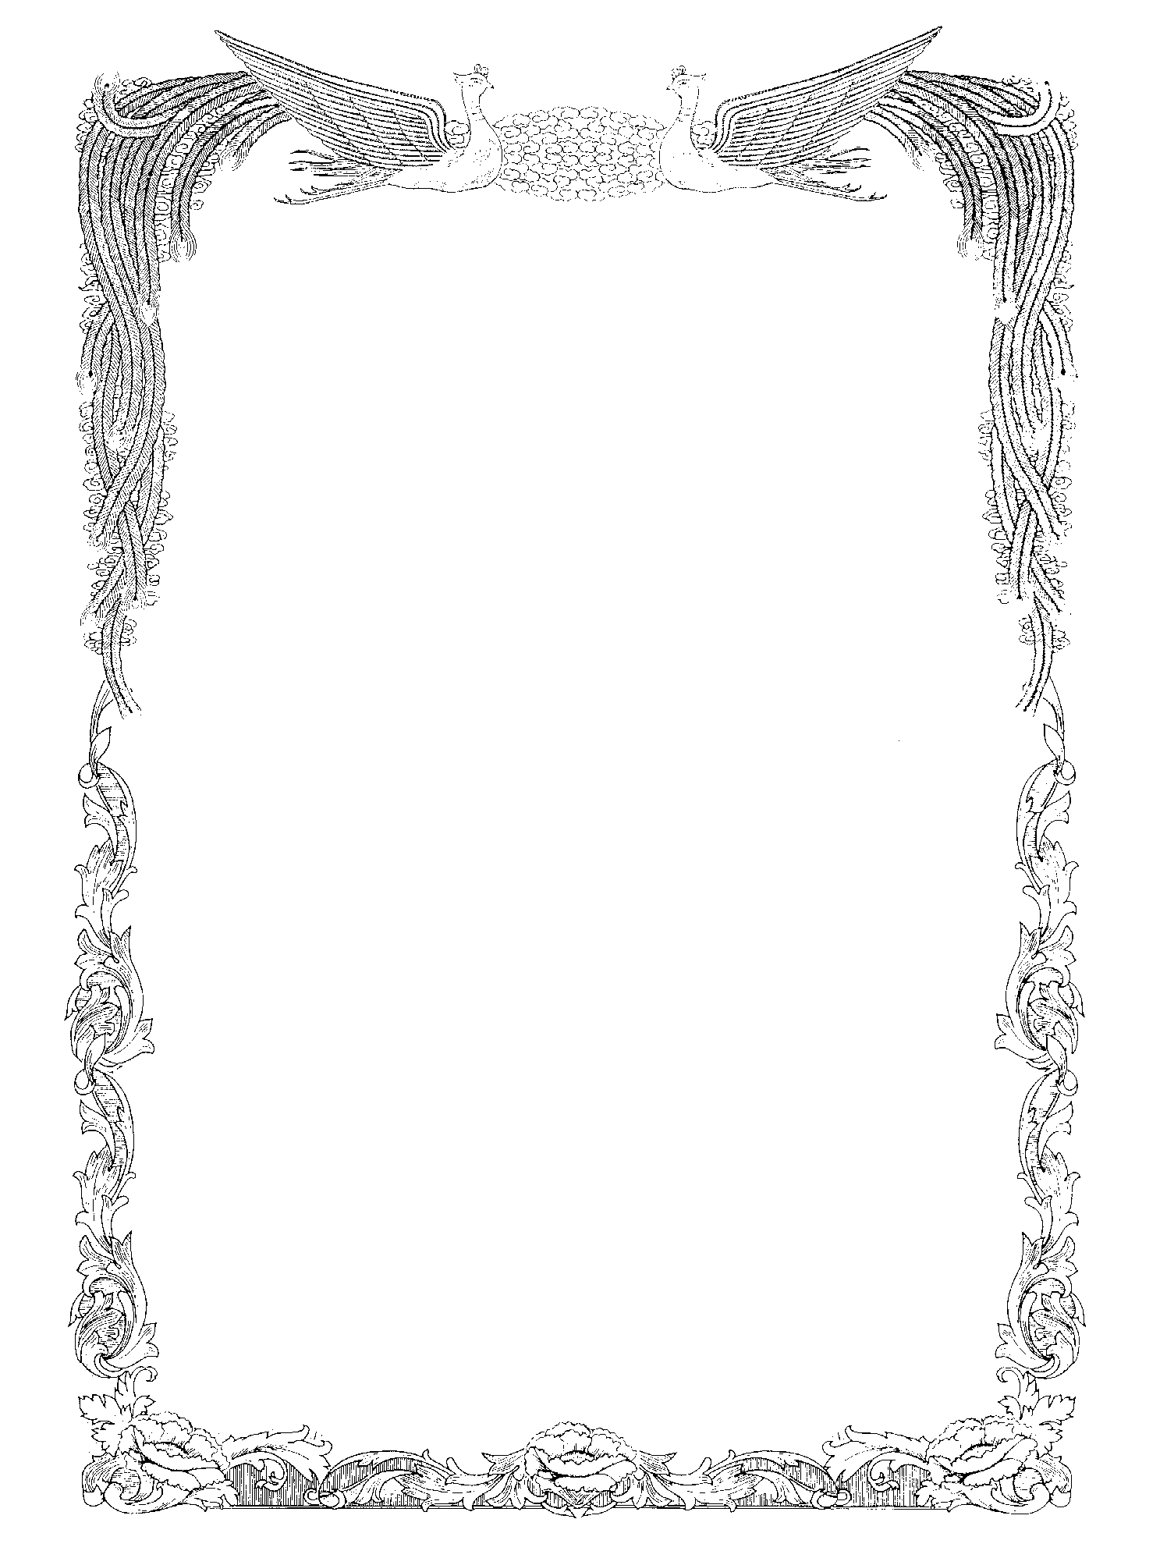８ 修了証

Aichi Prefectural

Reiwa Senior High School

校 章

John Smith

attended the General Course at Reiwa Senior High School
from September 1, 20XX to June 20, 20YY
and is therefore awarded this

Certificate of Attendance

Given by Aichi Prefectural
Reiwa Senior High School,
this month of June, 20YY

愛知 太郎
Taro AICHI
Principal

